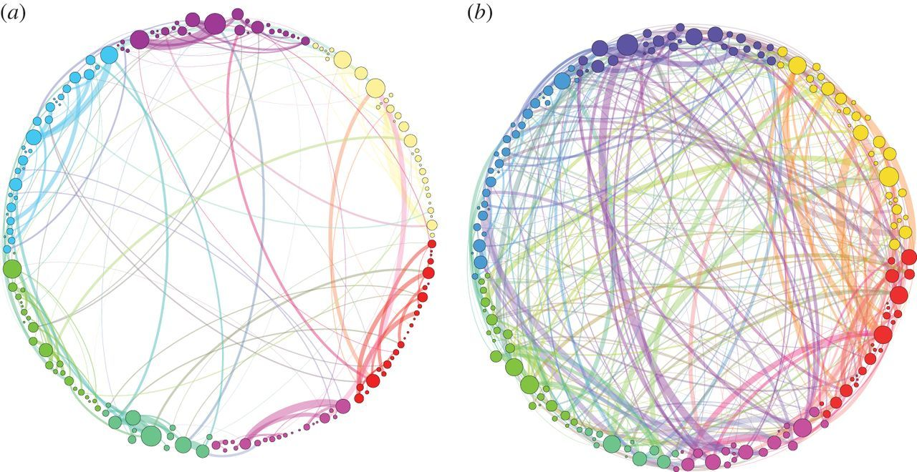

Simplified visualization of the persistence homological scaffolds.

Petri G, et al. *J R Soc Interface*. 2014;11(101):20140873.

Less Constrained, More Intercommunicative Brain Communication